Name: Soumya Sekhar Banerjee
Matriculation Number: 100004430
University: SRH University of Applied Science
Course: Masters in Engineering – Artificial Intelligence
Task 1: Dictionary Attack against a Spam Filter

Task1: Dictionary Attack against a Spam Filter

Abstract:

Spam filtering is a critical application of machine learning in modern communication systems, where automated classifiers must operate reliably in the presence of adversarial behavior. Classical approaches such as the multinomial Naive Bayes classifier remain widely used due to their simplicity and efficiency; however, their robustness against evasion attacks is limited. In this project, we investigate the impact of a dictionary-based adversarial attack on a Naive Bayes spam filter trained on the SMS Spam Collection dataset. The attack consists of appending legitimate-looking words to spam messages in order to bias the classifier toward the ham class without altering the underlying malicious intent. We conduct a controlled experiment in which the number of attacked spam messages is gradually increased and evaluate the resulting degradation in classification performance using accuracy and macro-averaged F1-score. The experimental results demonstrate that the Naive Bayes classifier is highly vulnerable to this form of evasion, with performance deteriorating significantly as the attack intensity increases. These findings highlight the limitations of bag-of-words models in adversarial settings and emphasize the need for more robust text representations and classification techniques for spam detection.

Aim of the experiment:

The aim of this experiment is to systematically analyze the robustness of a multinomial Naive Bayes spam classifier against a dictionary-based evasion attack. The experiment focuses on understanding how the classifier’s probabilistic decision mechanism, which relies on class-conditional word likelihoods and a bag-of-words representation, can be exploited by artificially increasing the frequency of ham-indicative tokens in spam messages. By injecting a controlled number of legitimate-looking words into spam messages at test time and progressively increasing the number of attacked messages, the study quantifies the effect of adversarial manipulation on the classifier’s posterior class probabilities. The impact of the attack is evaluated using accuracy and macro-averaged F1-score, enabling an assessment of both overall performance degradation and class-wise misclassification behavior. Ultimately, the experiment aims to demonstrate how linear evidence accumulation and the conditional independence assumption in Naive Bayes models lead to vulnerabilities under adversarial input perturbations.

Mathematical Intuition:

The multinomial Naive Bayes classifier models a text message as a bag-of-words count vector
$$x=(x_{1},x_{2},…,x_{V}),$$
where $x_{i}$denotes the number of occurrences of word $w_{i}$in the message and $V$is the vocabulary size. For each class $c∈\{\text{spam},\text{ham}\}$, the classifier estimates the posterior probability using Bayes’ rule:
$$P(c∣x)∝P(c)\prod_{i=1}^{V}{P(}w_{i}∣c)^{x_{i}}.$$
Taking the logarithm to avoid numerical underflow yields the decision function:
$$log⁡P(c∣x)=log⁡P(c)+\sum_{i=1}^{V}{x_{i}}log⁡P(w_{i}∣c).$$
Classification is performed by selecting the class with the maximum log-posterior probability.
In a dictionary attack, a spam message is modified by appending additional words that are statistically associated with the ham class. Mathematically, this increases the values of $x_{i}$for words $w_{i}$such that $log⁡P(w_{i}∣\text{ham})>log⁡P(w_{i}∣\text{spam})$. Each appended “good word” therefore contributes a positive additive term to the ham score while leaving the spam score largely unchanged. Because the Naive Bayes decision function is linear in the word counts, the cumulative contribution of these added ham-indicative words can outweigh the contribution of the original spam-indicative words.
As a result, even though the semantic meaning of the message remains spam-like, the posterior probability for the ham class becomes larger than that for the spam class, causing the classifier to misclassify the message. This vulnerability arises directly from the conditional independence assumption and the linear accumulation of evidence in the multinomial Naive Bayes model.

Task Overview and flowchart:

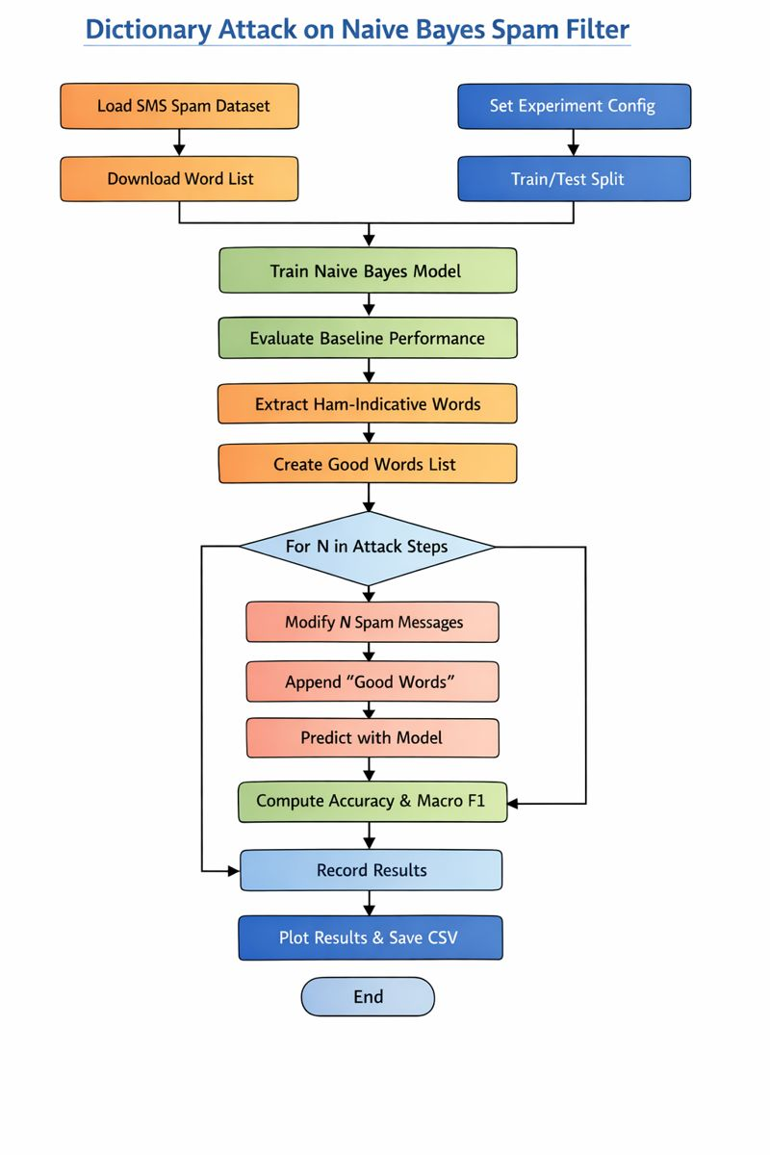

Concept summary:

- Algorithm: Train a Multinomial Naive Bayes spam classifier, append ham-indicative dictionary words to increasing numbers of spam messages at test time, and evaluate performance degradation using accuracy and macro-F1.
- Input: Labeled SMS spam dataset, external dictionary of common words, and fixed experimental parameters.
- Output: Accuracy and macro-F1 scores showing the impact of the dictionary attack as the number of attacked messages increases.

Model Training:

The SMS dataset is first split into training and testing subsets. During the model training phase, the training messages are transformed into bag-of-words count vectors using a CountVectorizer, and a Multinomial Naive Bayes classifier is trained to learn class-conditional word probabilities for spam and ham. After training, the model is evaluated on clean test data to establish a baseline. Selected spam messages in the test set are then modified by appending ham-indicative dictionary words, and the trained model classifies these adversarial examples. The effect of the attack is analyzed by measuring changes in accuracy and macro-averaged F1-score as the number of attacked messages increases.

Model Evaluation and Result evaluation:

Baseline Numerical Results (No Attack)
From the notebook output (clean test set, $N=0$):
- Accuracy ≈ 0.984
- Macro-averaged F1-score ≈ 0.964
Interpretation
- An accuracy of 98.4% indicates that the Multinomial Naive Bayes model performs very well under normal conditions.
- A macro-F1 score of 0.964 shows that both classes (spam and ham) are being classified well, even though the dataset is imbalanced.
- This confirms that the classifier is effective before any adversarial manipulation.

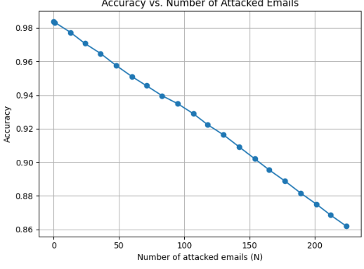

Graph 1: Accuracy vs Number of Attacked Emails
Observed behavior
- At $N=0$attacked messages, accuracy starts at approximately 0.98.
- As the number of attacked spam messages increases, the accuracy curve shows a consistent downward trend.
- When a large fraction of spam messages are attacked, accuracy drops noticeably (as shown in the plotted curve).
Explanation using numbers
- Initially, nearly 98 out of every 100 messages are classified correctly.
- As more spam messages are modified with ham-like words, an increasing number of spam messages are misclassified as ham.
- Each misclassified spam message reduces the total accuracy, causing the gradual decline observed in the graph.
Key insight
Even though the classifier starts with very high accuracy, a relatively simple dictionary attack can steadily erode this performance.

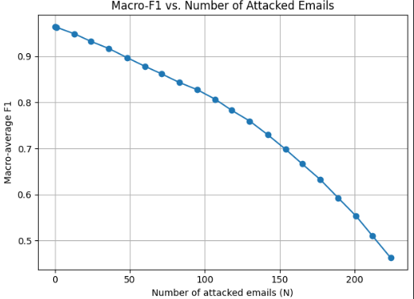

Graph 2: Macro-F1 Score vs Number of Attacked Emails
Observed behavior
- The macro-F1 score begins at approximately 0.96 when no attack is applied.
- As $N$increases, the macro-F1 score decreases faster and more sharply than accuracy.
Explanation using numbers
- The macro-F1 metric gives equal importance to spam and ham.
- As attacked spam messages are increasingly misclassified:
  - Spam recall drops significantly
  - Spam F1-score decreases
- Even if ham classification remains strong, the reduction in spam F1-score pulls the macro average down.
For example:
- A drop from 0.96 → lower values reflects that the model is failing specifically on the spam class, even when overall accuracy may still appear relatively high.
Key insight
Macro-F1 is more sensitive to the attack because it exposes the classifier’s growing inability to detect spam.

Overall Result Interpretation
- The baseline results (Accuracy ≈ 0.984, Macro-F1 ≈ 0.964) show that Multinomial Naive Bayes is a strong classifier under benign conditions.
- The graphs clearly demonstrate that as the number of attacked messages increases:
  - Accuracy decreases steadily
  - Macro-F1 decreases more aggressively
- This confirms that the classifier’s decision function can be manipulated by appending ham-indicative words.

Conclusion:

In this project, a multinomial Naive Bayes spam classifier was implemented and evaluated under a dictionary-based evasion attack using the SMS Spam Collection dataset. While the classifier achieved strong baseline performance on clean data, the experimental results demonstrated a significant vulnerability to adversarial manipulation. By appending ham-indicative words to spam messages at test time, the attacker was able to systematically reduce the classifier’s effectiveness. Both accuracy and macro-averaged F1-score degraded as the number of attacked messages increased, with the macro-F1 metric revealing a pronounced decline in spam detection capability. These findings confirm that the linear evidence accumulation and conditional independence assumptions inherent in bag-of-words Naive Bayes models make them particularly susceptible to simple evasion strategies, even when the semantic meaning of the message remains unchanged.

Reference:
- http://gnjatovic.info/machinelearning/adversarial.attacks.against.spam.filters.pdf
- https://youtu.be/YncZ0WwxyzU?si=9vcuHn5F-bM_x6L0
- ChatGpt
- Udemy

